1. 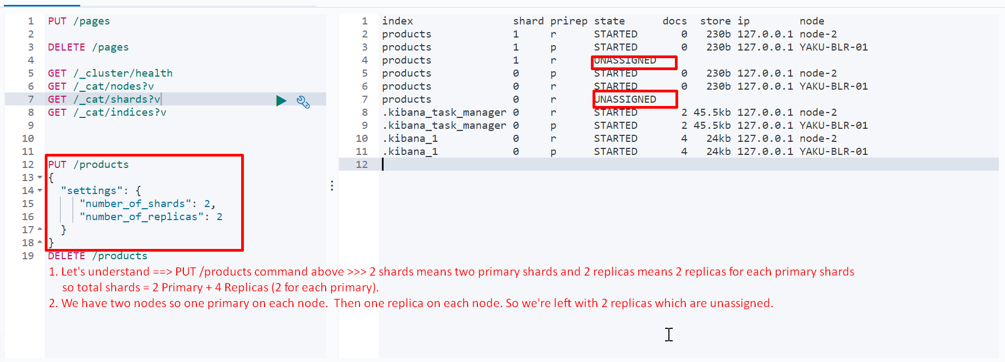
2. **NOTE**: Total shards and their distribution formula.
   1. One index may have many primary shards and for each shard, there may be many replicas.  
      Actually here is the formula 🡺   
      Total no shards = P * R where P is no of primary shards and R is no of its replicas.
   2. Take concrete example 🡺 3*4
   3. Let’s 2 be no of nodes.
   4. On each node, we put exactly one primary shard so 1 primary shard left behind out of 3.
   5. On each node, we put exactly one replica shard so 2 replica shards left behind out of 10.  
      **Assigned Shard** = Shard which is assigned to some node
3. When indexing (storing document)
   1. Only on assigned shards, document is stored.
4. POST /products/100 🡸 If this id document is not found, would be added as new one.